37.10: a) 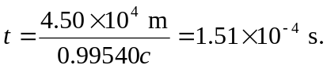
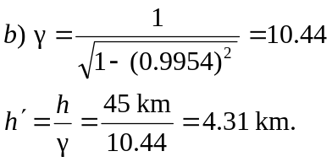
c) 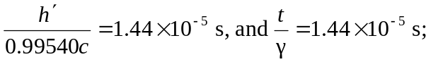so the results agree but the particle’s lifetime is dilated in the frame of the earth.

